Bebikaan-ezhiwebiziwinan Nimkii: The Adventures of Nimkii
A bilingual children’s book that celebrates
language and nature

In this beautifully illustrated children’s book, readers will experience the world in a new way as they see the seasons through the joyful eyes of Nimkii, a fun, nature-loving dog who will teach them a whole new language: Ojibwemowin, a language spoken by the indigenous tribes in parts of Michigan, Ontario, northern Minnesota and Wisconsin, and Alberta.

Whether hunting for maple trees in the fall, playing in the snow in the winter, enjoying the spring showers, or swimming in the summer, Nimkii seeks out activities that allow her to enjoy her natural surroundings. Fun and inspiring, this bilingual book helps children and adults communicate in new ways while exploring different elements of culture.

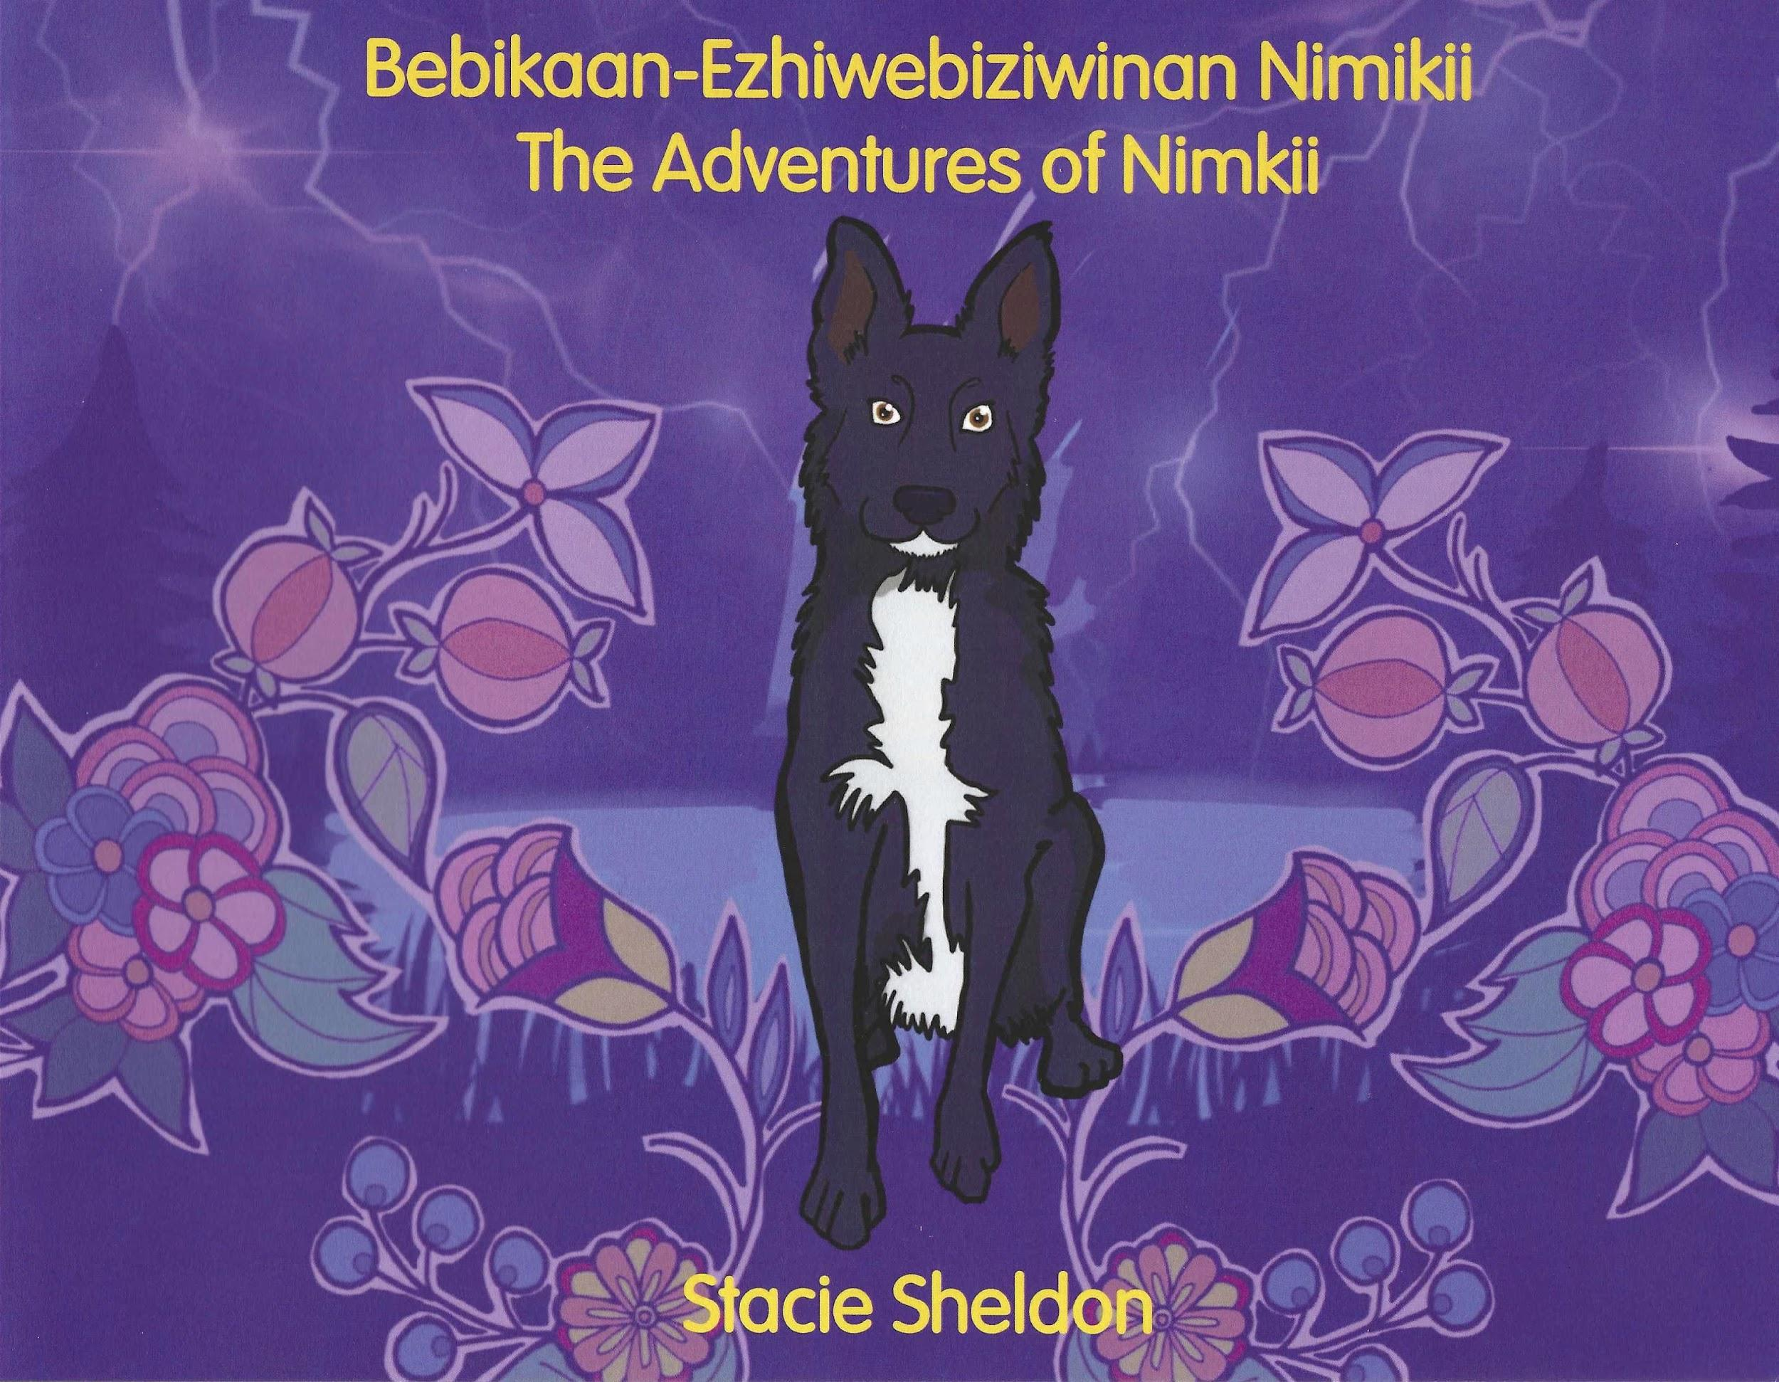
Title: Bebikaan-ezhiwebiziwinan Nimkii:
The Adventures of Nimkii

Story by: Stacie Sheldon; Translation by: Margaret Noodin;
Illustrations by: Rachel Butzin

Publication Date: July 2021 | Price: $16

ISBN: 978-1-7365519-1-2 | 32 pages | Hardcover
Category: Children’s Literature

Stacie Sheldon, the author, belongs to the Crane clan and is originally from Cheboygan, Michigan. She is a co-founder and leads the technical development of www.ojibwe.net. She also served on the Board of Directors for American Indian Services in Lincoln Park, Michigan.

Margaret Noodin, the translator, belongs to the Pine Marten Clan. She received an MFA in Creative Writing and a PhD in English and Linguistics from the University of Minnesota. She is currently a Professor at the University of Wisconsin-Milwaukee where she also serves at the Director of the Electa Quinney Institute for American Indian Education and the Associate Dean of the Humanities. She teaches and writes in Anishinaabemowin to contribute to the continuation of the language.

Rachel Butzin, the illustrator, is an Indigenous artist whose work is a reflection of her diverse heritage as well as her love of the environment, comic books, and pop culture. Rachel is a graduate of Michigan State University and currently resides in South Dakota with her family, where she is an art teacher at a Native American School.

